Chapter 14, Problem 64.

Obtain the transfer function of the active filter in Fig. 14.91. What kind of filter is it?

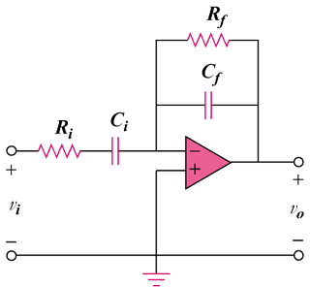

Figure 14.91
For Prob. 14.64.

